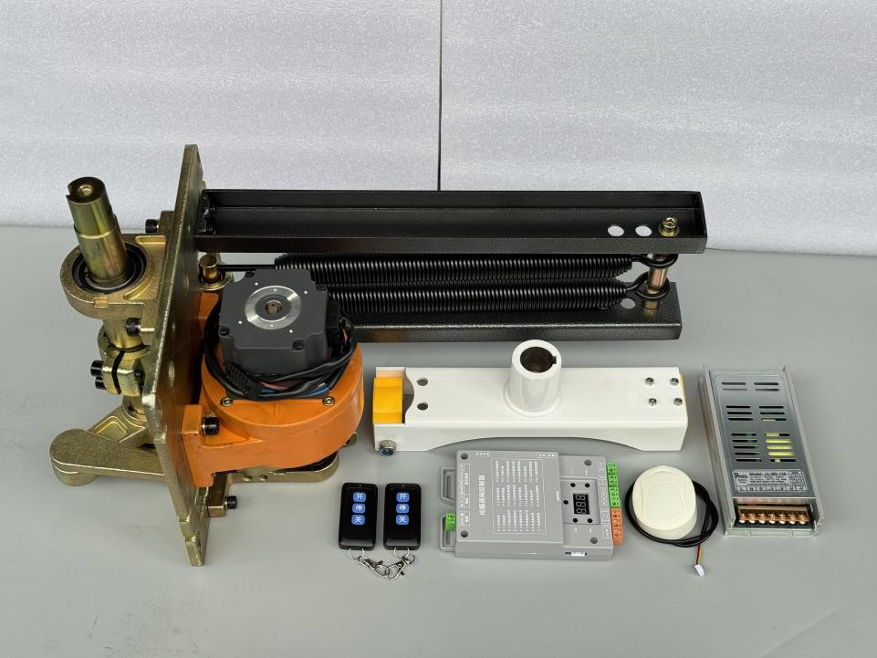
Specification of High-Speed Barrier Gate Mechanism and Control Driver
Item | Parameter | Remark
Rated operating voltage | 24VDC
Motor operating voltage | 24VDC
Rated power of single motor | 300W
Rated operating current of motor | 12.5A
Motor speed | 3000rpm
MCBF | ≥2,000,000 cycles
Dimensions | 300(L)*270(D)*616(H)mm
Applicable arm length | ≤6m(straight arm)，5m(fence arm)
Life-cycles | ≥10,000,000 cycles
Single-trip running time | 0.9–6s,adjustable(aluminum arm)  0.7–6s,adjustable(carbon fiber arm)
Temperature rise | ≤15℃
Running noise | ≤60dB
Controller dimensions | 176.6(H)*103(W)*25(D)mm
Altitude | ≤2000m
Operating temperature | -35-70℃
Operating humidity | ≤95%，non-condensing

